AI Lab 10 Submission

Name: Yash Raj
Roll Number: 24k-0737

Task01:
import pandas as pd
import numpy as np
from sklearn.model_selection import train_test_split
from sklearn.linear_model import LinearRegression
from sklearn.metrics import mean_squared_error , mean_absolute_error , median_absolute_error , r2_score
from sklearn.preprocessing import LabelEncoder
np.random.seed(42)
n = 200
data = pd.DataFrame(
{
"Study_Hours": np.random.normal(5, 2, n),
"Attendance": np.random.normal(80, 10, n),
"Previous_grade": np.random.normal(70, 15, n),
"internet_usage": np.random.normal(3, 1.5, n),
"participation": np.random.choice(["Low","Medium","High"], n),

}
)

participation_map = {
"Low": 0,
"Medium": 5,
"High": 10,}

data["Final_Score"] =(
data["Study_Hours"]*5 +
data["Attendance"]*0.3 +
data["Previous_grade"]*0.4 +
data["internet_usage"]* -2 +
data["participation"].map(participation_map) +
np.random.normal(0, 5, n)
)

data["Attendance"].fillna(data["Attendance"].mean(), inplace=True)
data["Study_Hours"].fillna(data["Study_Hours"].mean(), inplace=True)

le = LabelEncoder()
data["participation"] = le.fit_transform(data["participation"])

x= data.drop("Final_Score", axis=1)
y = data["Final_Score"]
x_train, x_test, y_train, y_test = train_test_split(x, y, test_size=0.2)

model = LinearRegression()
model.fit(x_train, y_train)

y_pred = model.predict(x_test)
mse = mean_squared_error(y_test, y_pred)
mae = mean_absolute_error(y_test, y_pred)
r2 = r2_score(y_test, y_pred)
print("MSE :",mse)
print("MAE :",mae)
print("R2 Score :",r2)

new_student = pd.DataFrame(
[
{
"Study_Hours":6,
"Attendance":85,
"Previous_grade":75,
"internet_usage":2,
"participation":2,

}
]
)
new_student["participation"] = le.fit_transform(new_student["participation"])
prediction = model.predict(new_student)

Output:
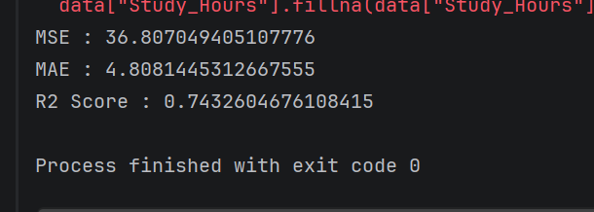
Task02:
import numpy as np
import pandas as pd
from sklearn.linear_model import LogisticRegression
from sklearn.tree import DecisionTreeClassifier
from sklearn.model_selection import train_test_split
from sklearn.metrics import accuracy_score
from sklearn.metrics import confusion_matrix
from sklearn.metrics import classification_report
from sklearn.metrics import precision_score
from sklearn.metrics import recall_score
from sklearn.metrics import f1_score
from sklearn.preprocessing import LabelEncoder

np.random.seed(42)
n= 200
data = pd.DataFrame(
{
"Income": np.random.normal(50000, 10000, n),
"Employment_status": np.random.choice(["Employed", "Not employed","Self-Employed"], n),
"Credit_score": np.random.normal(650, 50, n),
"Loan_amount": np.random.normal(20000,5000, n),
"Marital_status": np.random.choice(["Single","Married"],n),
}
)

data["Loan_Approved"] = (
(data["Income"] > 45000) & (data["Credit_score"] > 600)
).astype(int)

data.loc[np.random.randint(0,n,10),"Income"] = np.nan
data["Income"]= data["Income"].fillna(data["Income"].mean())

le_emp = LabelEncoder()
le_mar = LabelEncoder()

data["Employment_status"] = le_emp.fit_transform(data["Employment_status"])
data["Marital_status"] = le_mar.fit_transform(data["Marital_status"])

x = data.drop("Loan_Approved", axis=1)
y = data["Loan_Approved"]

x_train, x_test, y_train, y_test = train_test_split(x, y, test_size=0.2)

model = DecisionTreeClassifier()
model.fit(x_train, y_train)

y_pred = model.predict(x_test)
print("Classification Report :")
print(classification_report(y_test, y_pred))
print("Confusion Matrix :",confusion_matrix(y_test, y_pred))

new_applicant = pd.DataFrame(
[
{
"Income": 60000,
"Employment_status": le_emp.transform(["Employed"])[0],
"Credit_score": 700,
"Loan_amount": 15000,
"Marital_status": le_mar.transform(["Married"])[0]
}
]
)

prediction = model.predict(new_applicant)
print("Loan Approval Prediction",prediction[0])

Output:
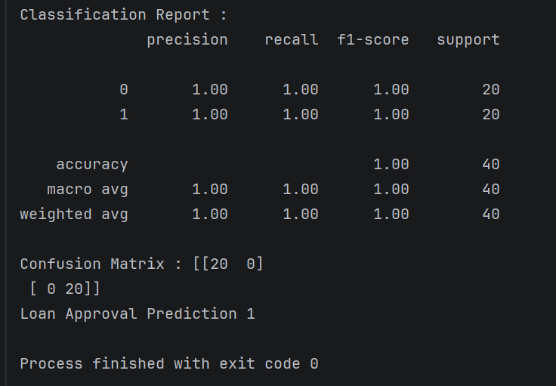

Task03:
import numpy as np
import pandas as pd
from sklearn.ensemble import RandomForestClassifier
from sklearn.svm import SVC
from sklearn.model_selection import train_test_split
from sklearn.metrics import classification_report, confusion_matrix
from sklearn.preprocessing import StandardScaler, LabelEncoder

np.random.seed(42)
n = 200

data = pd.DataFrame({
"Monthly_Charges": np.random.normal(70, 20, n),
"Contract_Type": np.random.choice(["Month-to-month", "One year", "Two year"], n),
"Tenure": np.random.randint(1, 72, n),
"Internet_Service": np.random.choice(["DSL", "Fiber", "None"], n),
"Support_Calls": np.random.randint(0, 10, n)
})

data["Churn"] = (
(data["Monthly_Charges"] > 80) &
(data["Support_Calls"] > 5) &
(data["Tenure"] < 12)
).astype(int)

data.loc[np.random.randint(0,n,10), "Monthly_Charges"] = np.nan
data["Monthly_Charges"] = data["Monthly_Charges"].fillna(data["Monthly_Charges"].mean())

data["Monthly_Charges"] = np.clip(data["Monthly_Charges"], 10, 150)

le_contract = LabelEncoder()
le_internet = LabelEncoder()

data["Contract_Type"] = le_contract.fit_transform(data["Contract_Type"])
data["Internet_Service"] = le_internet.fit_transform(data["Internet_Service"])

X = data.drop("Churn", axis=1)
y = data["Churn"]

scaler = StandardScaler()
X_scaled = scaler.fit_transform(X)

x_train, x_test, y_train, y_test = train_test_split(X_scaled, y, test_size=0.2, random_state=42)

r = RandomForestClassifier()
r.fit(x_train, y_train)

svm_model = SVC(kernel="linear")
svm_model.fit(x_train, y_train)

y_pred = r.predict(x_test)

print("Classification Report:\n", classification_report(y_test, y_pred))
print("Confusion Matrix:\n", confusion_matrix(y_test, y_pred))

importance = r.feature_importances_
for i, col in enumerate(X.columns):
print(f"{col}: {importance[i]}")

new_customer = pd.DataFrame([{
"Monthly_Charges": 90,
"Contract_Type": le_contract.transform(["Month-to-month"])[0],
"Tenure": 5,
"Internet_Service": le_internet.transform(["Fiber"])[0],
"Support_Calls": 7
}])

new_customer_scaled = scaler.transform(new_customer)
prediction = r.predict(new_customer_scaled)

print("Churn Prediction:", prediction[0])

Output:
